
Student Name: Jack Walker
Submission Date: 10/14/25

Business Overview
Walker’s Trumpet Shop
I will be selling trumpets through an online marketing system, allowing me to reach many more customers compared to a traditional local system. This specific project will allow me to print out a more detailed receipt for what the user has bought, featuring shipping cost, a flat rate discount, and a calculator for the final price given a certain number of items purchased. Our companies mission statement is to sell trumpets with the intent of sharing the gospel with every sale, to try and further the teachings of Christ, in accordance with Matthew 28:19-20. Our vision statement is to begin selling all different kinds of trumpets, and eventually even break into the market of quality flugelhorns and cornets.

Scope of Work (Algorithm)
The following section should be completed BEFORE you start coding in Visual Studios:
General Overview | - Have program in which a user can input how many items they plan on purchasing, as well as, being able to choose whether they pay for shipping or if they want a discount.  - Should be able to print out a detailed receipt.  - On the receipt, it should not have items that aren’t used, for instance a shipping line that has zero dollars in shipping
Business Purpose | - This allows my company to print more detailed receipts for the user, and also allows us to keep track more thoroughly of how many customers we have, through those receipts
Approach | - Make the main structure of the program  - Declare variables  - Open the input file  - Have a while loop that iterates through the user defined portion of the code, for as long as the user wants to stay there  - Print out a menu that the user can choose from  - Depending on what the user chose, add that choice to the final price  - Calculate the final price  - Have Boolean values associated with each option to keep track of whether the user interacted with that option  - Print out the final receipt, only the necessary information

Functions Overview
For each of the functions that you implement in this project, document the prototype and its’ purpose within your program:
Main() | - Prints out a menu, takes the user input, and prints out a receipt from that
Function Prototype | - I did not see how another function could be very helpful in this certain situation
Continue to add rows as necessary! | ...

Integrity Statements
By signing the document below, I affirm that:
Source Code | - I have not shared the source code in my program with anyone other than my instructor’s approved human sources.  - I have not used source code obtained from another student, or any other unauthorized source, either modified or unmodified.
Authorized Sources | - I have not used ChatGPT or any other similar site for progress on this assignment  - If any source code or documentation used in my program was obtained from another authorized source, such as a text book or course notes, that has been clearly noted with a proper citation in the comments of my program.
Normal Operations | - I have not knowingly designed this program in such a way as to defeat or interfere with the normal operation of any machine it is graded on or to produce apparently correct results when in fact it does not
Signature | Jackson Walker

Screenshots
In this box, include a screenshot of your program running properly to demonstrate that your solution does compile:

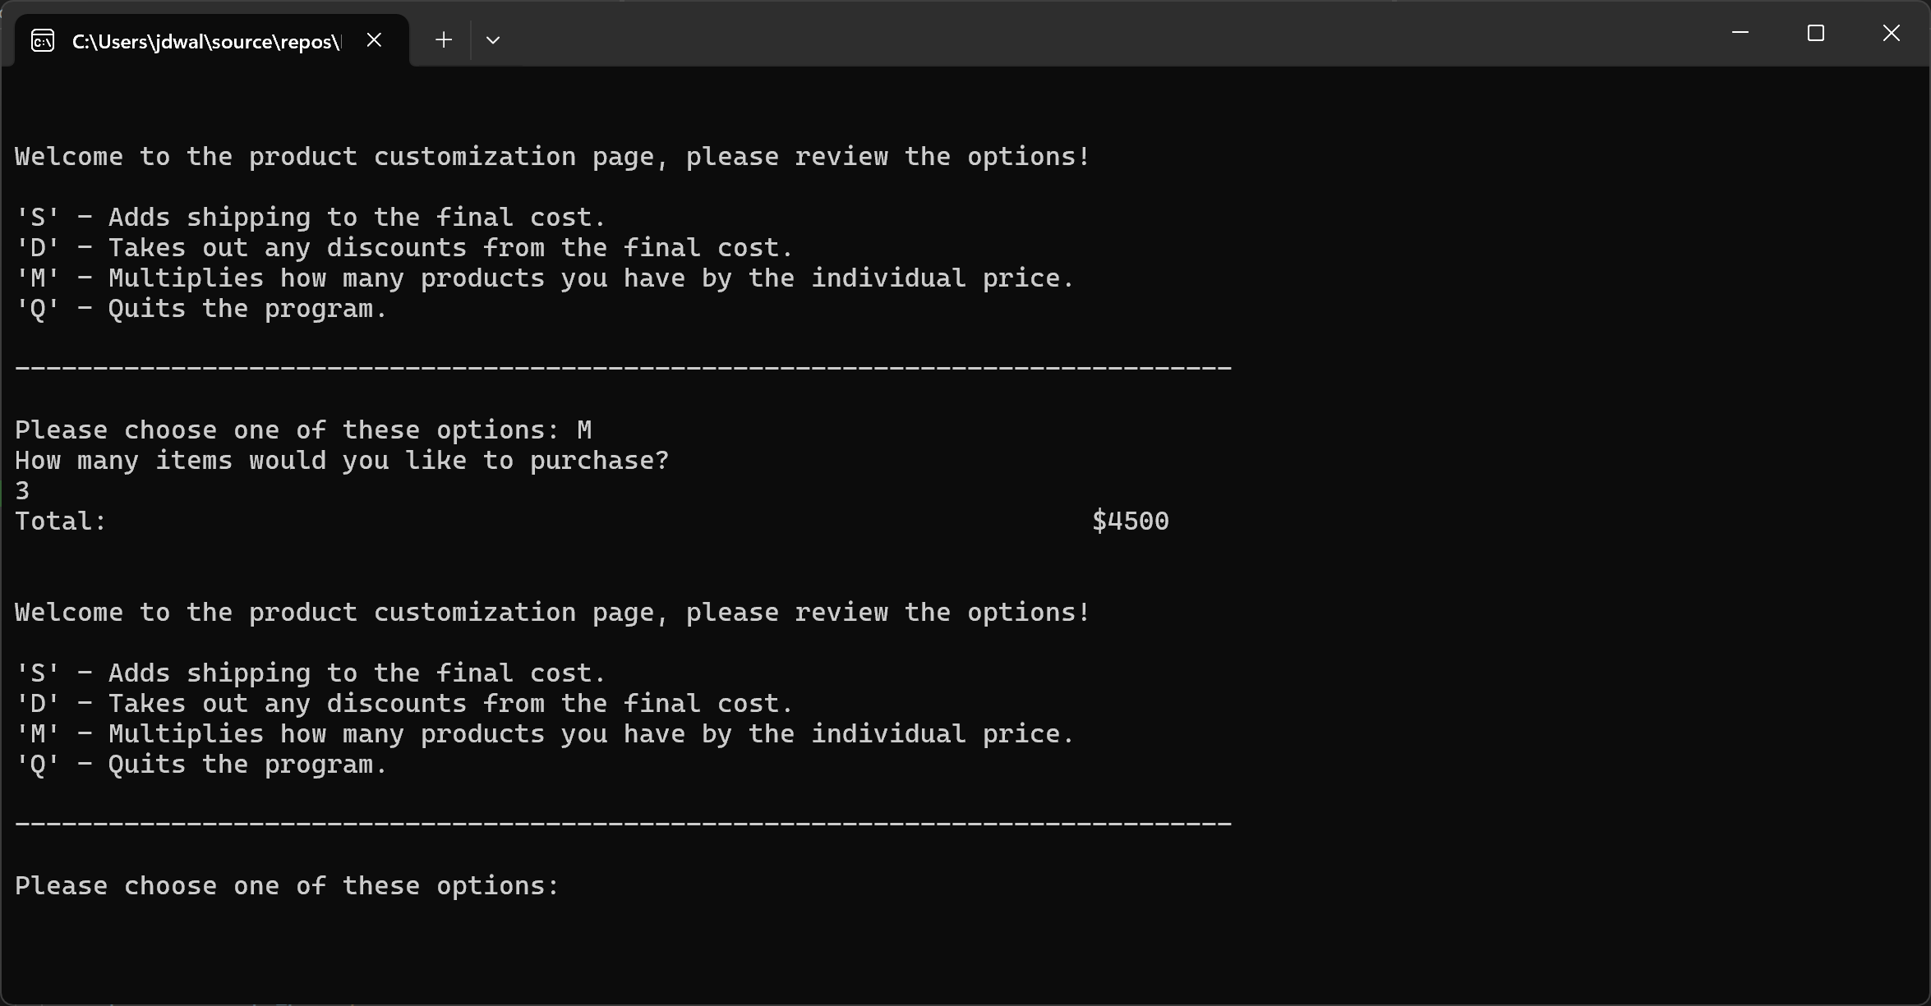
In this box, include a screenshot showing your Git commit messages as you worked through implementing each major step as provided in the approach listed above:

